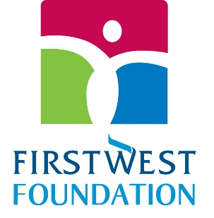

2024 Envision Financial Employees’ Endowment Awards $15,934 in Grants

$1,434 – Cyrus Centre | Chilliwack
https://www.cyruscentre.com/

$2,000 – Storehouse Community Hub Society| Cloverdale Community Kitchen
https://www.mycck.ca

$1,000 – Amici Curiae Friendship Society | BC wide
https://www.legalformsbc.ca/#/

$2,500 – Fraser River Aboriginal Friendship Centre Association | Surrey
https://frafca.org/

$2,000 – Guru Nanak Food Bank | Delta
https://gnfoodbank.com/home

$2,500 – Raphael Family Support Foundation (Raphael’s House) | Langley
https://raphaelhouse.ca/

$3,000 – Tamitik Status for Women | Kitimat
https://tamitik.ca/

$1,500 – Volunteer Cancer Drivers Society | Fraser Valley wide
https://volunteercancerdrivers.ca/

