**Enderby Financial Community Endowment

**2024 Grants | $37,000 awarded to four charities**

## **IMPACT GRANTS**

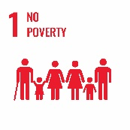**Impact Grants** are unrestricted grants, investing in an organization’s operations, programs, projects or services.

**Enderby and District Community Resource Centre**, Enderby, $15,000

Outreach Worker/Community Support Program provides direct support to families in the community offering intense parenting support, referrals, crisis intervention, short term counseling and life skills. Funding will support current work with additional hours for the program facilitator.

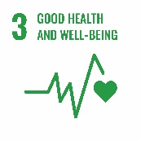

**Mothers Against Drunk Drivers – MADD,** Enderby Region, $3,000 (Multi-year recipient)

School Assembly Program teaches youth in grades 7-12 new skills and information including the consequences of impaired driving, alternatives to impaired driving, to plan and call 911 if they see a suspected impaired driver.

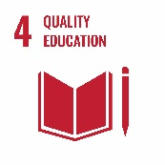

**Literacy Alliance of the Shuswap Society,** Enderby, $10,000

Summer Literacy Program– Three-week summer literacy program aimed to engage lower-income kids in a fun supportive environment, designed to promote literacy, build community, and enhance self-esteem.

**Kingfisher Interpretive Centre,** Enderby, $9,000

Conservation Through Education provides an opportunity for local children (grades K-12) to learn about our local environmental sustainability, systems support, and salmon lifecycle.